Symmetric Figures

http://my.homecampus.com.sg/Learn/Primary-Grade-4/Geometry/Symmetric-Figures-Shapes-and-Patterns

What is a symmetric figure?
If a figure can be folded or divided into half so that the two halves match exactly then such a figure is called a symmetric figure. The figures below are symmetric.
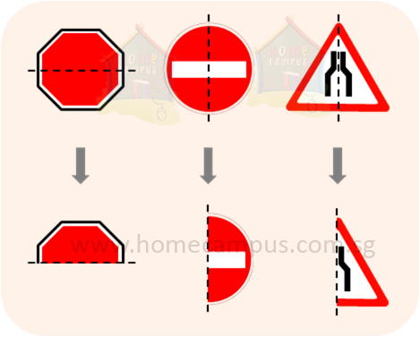
The dotted line in each of the symmetric figures above that divides the figure into two equal halves is called the line of symmetry.

In the figures below, there are no lines of symmetry that divide each of the figures into two equal halves. Therefore, these figures are not symmetric.
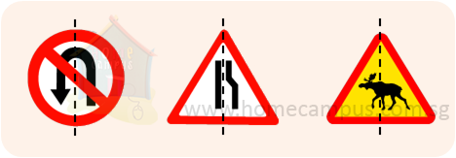

Line of Symmetry = Line of Reflection

Folding Test
You can find if a shape has a Line of reflection (is symmetric)
by folding it.
When the folded part sits perfectly on top (all edges matching), then the fold line is a Line of Reflection
Here I have folded a rectangle one way, and it didn't work.
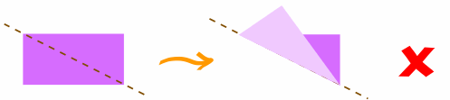
So this is not a Line of Reflection
But when I try it this way, it does work (the folded part sits perfectly on top, all edges matching):
So this is a Line of Reflection

